**Introduction to machine learning lesson**

Thanks to machine learning, exciting changes are happening across all areas of society, including:

* Recent advancements in industries such as autonomous vehicles.
* Accurate and rapid translation of the text into hundreds of languages.
* AI assistants you might find in your home.
* Worker safety improvements.
* Quicker pharmaceutical design and development.

Machine learning is a complex subject area. In this article I will introduce machine learning, some of the most common terms and ideas used in machine learning and different steps involved in machine learning.

Machine learning (ML) is a modern software development technique, and a type of artificial intelligence (AI), that enables computers to solve problems by using examples of real-world data. It allows computers to automatically learn and improve from experience without being explicitly programmed to do so.

Machine learning is part of the broader field of artificial intelligence. This field is concerned with the capability of machines to perform activities using human-like intelligence. Within machine learning there are several different kinds of tasks or techniques:

* In **supervised learning**, every training sample from the dataset has a corresponding label or output value associated with it. As a result, the algorithm learns to predict labels or output values..
* In **unsupervised learning**, there are no labels for the training data. A machine learning algorithm tries to learn the underlying patterns or distributions that govern the data.
* In **reinforcement learning**, the algorithm figures out which actions to take in a situation to maximize a reward (in the form of a number) on the way to reaching a specific goal. This is a completely different approach than supervised and unsupervised learning.

**How is machine learning different?**

In traditional problem-solving with software, a person analyzes a problem and engineers a solution in code to solve that problem. For many real-world problems, this process can be laborious (or even impossible) because a correct solution would need to take a vast number of edge cases into consideration.

In machine learning, the problem solver abstracts away part of their solution as a flexible component called a model, and uses a special program called a model training algorithm to adjust that model to real-world data. The result is a trained model which can be used to predict outcomes that are not part of the dataset used to train it.

In a way, machine learning automates some of the statistical reasoning and pattern-matching the problem solver would traditionally do.

The overall goal is to use a model created by a model-training algorithm to generate predictions or find patterns in data that can be used to solve a problem

**Understanding the terminology?**

Machine learning is a new field created at the intersection of statistics, applied math, and computer science. Because of the rapid and recent growth of machine learning, each of these fields might use slightly different formal definitions of the same terms.

**Terminology**

**Machine learning**, or ML, is a modern software development technique that enables computers to solve problems by using examples of real-world data.

Terms in machine learning you may know

* **Clustering** is an unsupervised learning task that helps to determine if there are any naturally occurring groupings in the data.
* A **categorical label** has a discrete set of possible values, such as "is a cat" and "is not a cat."
* A **continuous (regression) label** does not have a discrete set of possible values, which means there are potentially an unlimited number of possibilities.
* **Discrete** is a term taken from statistics referring to an outcome that takes only a finite number of values (such as days of the week).
* A **label** refers to data that already contains the solution.
* Using **unlabeled data** means you don't need to provide the model with any kind of label or solution while the model is being trained.

**Components of machine learning**

Nearly all tasks solved with machine learning involve three primary components:

* A machine learning model
* A model training algorithm
* A model inference algorithm

### **The clay analogy of machine learning**

You can understand the relationships between these components by imagining the stages of crafting a teapot from a lump of clay.

1. First, you start with a block of raw clay. At this stage, the clay can be molded into many different forms and be used to serve many different purposes. You decide to use this lump of clay to make a teapot.
2. So how do you create this teapot? You inspect and analyze the raw clay and decide how to change it to make it look more like the teapot you have in mind.
3. Next, you mold the clay to make it look more like the teapot that is your goal.

Congratulations! You've completed your teapot. You've inspected the materials, evaluated how to change them to reach your goal, and made the changes. The teapot is now ready for your enjoyment.

**What are machine learning models?**

A machine learning model, like a piece of clay, can be molded into many different forms and serve many different purposes. A more technical definition would be that a machine learning model is a block of code or framework that can be modified to solve different but related problems based on the data provided.

**Important**  
*A model is an extremely generic program (or block of code), made specific by the data used to train it. It is used to solve different problems.*

**Major steps in the machine learning process**

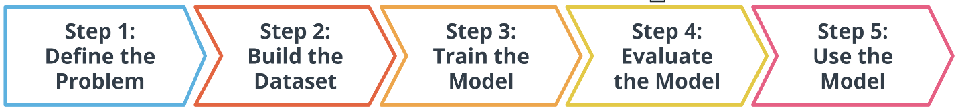

In the preceding diagram, you can see an outline of the major steps of the machine learning process. Regardless of the specific model or training algorithm used, machine learning practitioners practice a common workflow to accomplish machine learning tasks.

These steps are iterative. In practice, that means that at each step along the process, you review how the process is going. Are things operating as you expected? If not, go back and revisit your current step or previous steps to try and identify the breakdown.

**Step1: Define the problem**

To get started, it is important to follow these two important steps

**Step 1: Define a very specific task**

**Specific problem you want to solve have to be identify, example,** Now imagine that you own a shop store and you sell snow cone along with many other products. You wonder, "How do I increase sales?" It's a valid question, but it's the *opposite* of a very specific task.

**Step 2: Identify the machine learning task we might use to solve this problem**

* This helps you better understand the data you need for a project.

In this article, we will focus on two common machine learning tasks:

* Supervised learning
* Unsupervised learning

**Supervised and unsupervised learning**

The presence or absence of labeling in your data is often used to identify a machine learning task.

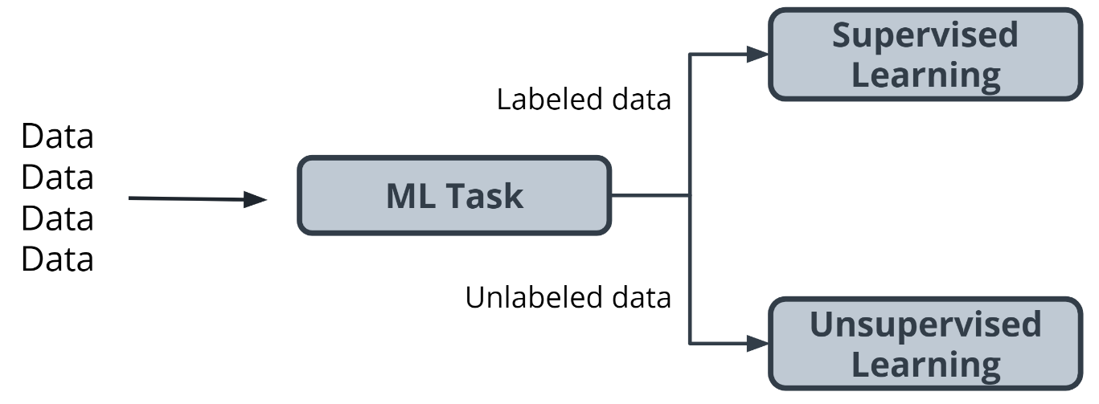

### **Supervised tasks**

A task is supervised if you are using labeled data. We use the term labeled to refer to data that already contains the solutions, called *labels*.

For example, predicting the number of snow cones sold based on the average temperature outside is an example of supervised learning.

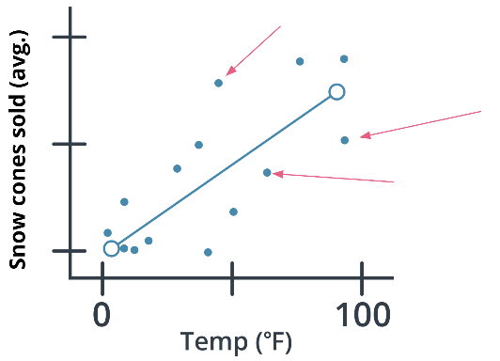

In the preceding graph, the data contains both a temperature and the number of snow cones sold. Both components are used to generate the linear regression shown on the graph, the goal was to predict the number of snow cones sold, and feed that value into the model. providing the model with labeled data and therefore, performing a *supervised machine learning task.*

### **Unsupervised tasks**

A task is considered to be unsupervised if you are using *unlabeled data*. This means you don't need to provide the model with any kind of label or solution while the model is being trained.  
Let's take a look at unlabeled data



* Take a look at the preceding picture. Did you notice the tree in the picture? What you just did, when you noticed the object in the picture and identified it as a tree, is called *labeling the picture*. Unlike you, a computer just sees that image as a matrix of pixels of varying intensity.
* Since this image does not have the labeling in its original data, it is considered *unlabeled.*

In **supervised learning**, there are two main identifiers that you will see in machine learning:

* A **categorical** label has a discrete set of possible values. In a machine learning problem in which you want to identify the type of flower based on a picture, you would train your model using images that have been labeled with the categories of the flower that you want to identify. Furthermore, when you work with categorical labels, you often carry out classification tasks, which are part of the supervised learning family.
* A **continuous** (regression) label does not have a discrete set of possible values, which often means you are working with numerical data

**Step 3: Building a dataset**

The next step in the machine learning process is to build a dataset that can be used to solve your machine learning-based problem. Understanding the data needed helps you select better models and algorithms so you can build more effective solutions.

The Four Aspects of Working with Data

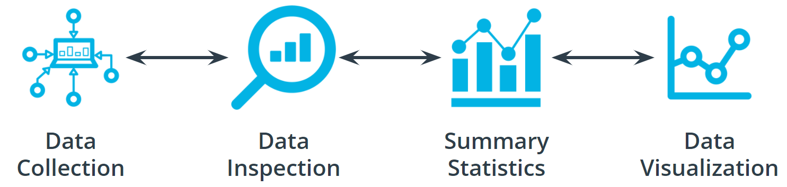

You can take an entire class just on working with, understanding, and processing data for machine learning applications. Good, high-quality data is essential for any kind of machine learning project. Let's explore some of the common aspects of working with data.

### Data collection

Data collection can be as straightforward as running the appropriate SQL queries or as complicated as building custom web scraper applications to collect data for your project. You might even have to run a model over your data to generate needed labels. Here is the fundamental question

Does the data you've collected match the machine learning task and problem you have defined?

Data inspection

The quality of your data will ultimately be the largest factor that affects how well you can expect your model to perform. As you inspect your data, look for:

* Outliers
* Missing or incomplete values
* Data that needs to be transformed or preprocessed so it's in the correct format to be used by your mode.

Summary statistics

Models can make assumptions about how your data is structured. Now that you have some data in hand, it is a good best practice to check that your data is in line with the underlying assumptions of the machine learning model that you chose.

Using statistical tools, you can calculate things like the mean, inner-quartile range (IQR), and standard deviation. These tools can give you insights into the scope, scale, and shape of a dataset.

Data visualization

You can use data visualization to see outliers and trends in your data and to help stakeholders understand your data.

Look at the following graphs, some data seems to have clustered into different groups. In the graph immediately preceding it, some data points might be outliers.

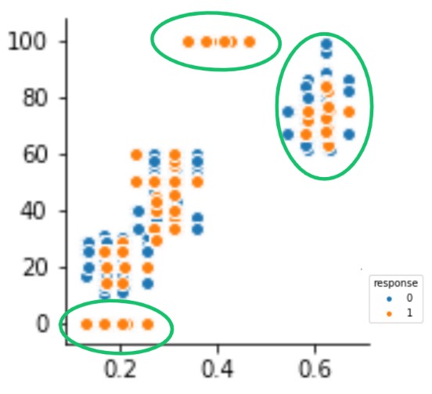

**Step 3: Modeling training**

Modeling training is a process whereby the model's parameters are iteratively updated to minimize some loss function that has been previously defined.

The first step in model training is to randomly split the dataset

This allows you to keep some data hidden during training, so that the data can be used to evaluate your model before you put it into production.

Splitting your dataset gives you two sets of data:

* *Training dataset*: The data on which the model will be trained. Most of your data will be here. Many developers estimate about 80%.
* *Test dataset*: The data withheld from the model during training, which is used to test how well your model will generalize to new data.

**Step4: Evaluating a trained model**

After you have collected your data and trained a model, you can start to evaluate how well your model is performing. The metrics used for evaluation are likely to be very specific to the problem you defined.

**An iterative process**

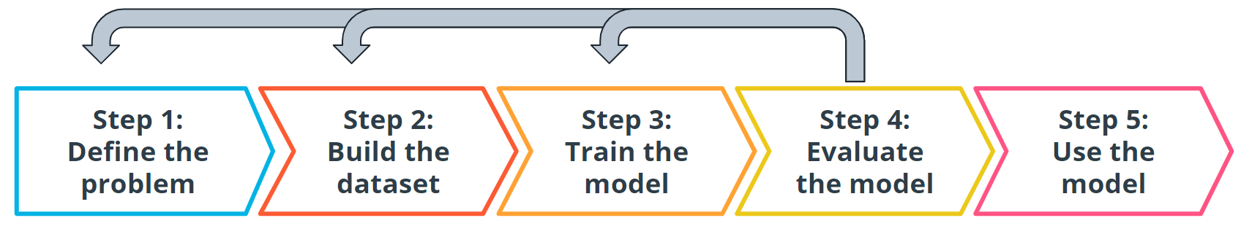

Every step we have gone through is highly iterative and can be changed or rescoped during the course of a project. At each step, you might find that you need to go back and reevaluate some assumptions you had in previous steps.

**Step5: Model inference**

Congratulations! You're ready to deploy your model. Once you have trained your model, have evaluated its effectiveness, and are satisfied with the results, you're ready to generate predictions on real-world problems using unseen data in the field. In machine learning, this process is often called **inference**.

**Machine learning is iterative**



Even after you deploy your model, you're always monitoring to make sure your model is producing the kinds of results that you expect. There may be times where you reinvestigate the data, modify some of the parameters in your model training algorithm, or even change the model type used for training.

Thank you for your time….